**LUXE-M-BURGER**

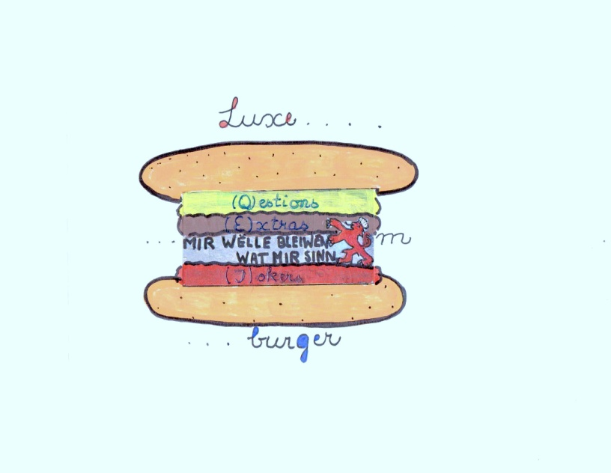

There are two strategies of getting to know Luxembourg country :

1. play this game and enjoy the country in an unconventional and safe way.
2. visit the country and remember the highlights of this game.

**Game :**

Number of playing teams ( pl.t.): two, each team with 1-3 players

***Equipment:***

1 game (map of Luxembourg with 12 cantons )

For each pl.t.: 1 dice, 1 token

2 sets of playing cards : set 1: (**Q**)=12 different questions about the cantons

set 2: (**E**)=12 extras about art, traditions, legends,

songs, games, comics, movies, walking trails, food, theater plays , museums , personalities.

For both pl. t.: 1 set of playing cards : set 3: (**J** )= 12 Joker cards with fun situations

***Additional equipment and informations*** :

(**Q**) : correct answers can mostly be found in:

Reference book : **Grand Duchy of Luxembourg (tourist guide)** **Editions Binsfeld**

**ISBN: 2-87954121-2**

(**E**): correct answers can mostly be found on the bottom of the back side (upside down )of the playing cards …but please think hard first before peeking .

(**J**): **note book + Biro** for some of the tasks

**CD player**

**CD** : **Letz fetz** ( [www.kk.1000.lu](http://www.kk.1000.lu)) or **Dram vu Letzebuerg** ([www.kk.1000.lu](http://www.kk.1000.lu))

***Game rules*** :

Each pl.t. chooses a token and 2 different sets of playing cards (Q+E ) - photos /pictures faced upwards .

The (J) playing cards won`t be used until the end of the game.

The game pattern ( shoe form) is divided into 12 cantons .The cantons have special hazards or benefits for the pl.t. landing on them ( marked on the playing cards )

The object of the game is travelling through the 12 cantons and catching a glimpse of tiny Luxembourg.

After passing through cantons 1-6 - by using one dice - the playing teams continue their way with two dices and advance through cantons 7-12.

**THERE IS NO WINNER OR LOSER IN THIS GAME !**

**GO !**

Both teams take turns rolling **one dice** .

The team scoring the highest number of dots on the dice starts the game and hops on a canton using its token .The sum of dots on the team`s dice is equivalent to the names of the cantons below .

**.** **Clervaux**

**..** **Vianden**

**…**  **Wiltz**

**…. Diekirch**

**….. Rédange**

**…… Mersch**

After having travelled through six cantons , each team goes on playing with **two dices**. The sum of dots on the team`s dices is equivalent to the names of the cantons below.

**..Echternach**

**...Capellen**

**….Grevenmacher**

**.....Remich**

**......Esch-Alzette**

**last stage :Luxembourg (no dice rolling)**

**Attention !**

After entering the game with the token , the pl.t. draws a playing card (Q) - corresponding to the canton entered - and answers the question.

If there are more players in your team , they should take turns in :

a) rolling the dice ( later the dices)

b) drawing a card and formulating a question

c) giving **one single** answer.

This will give each player an opportunity of remaining active in the game.

**If the answer is right** ,C:\Users\dupong\AppData\Local\Microsoft\Windows\Temporary Internet Files\Content.IE5\IS5HL2KI\MC900440452[1].wmf the pl.t. is allowed to draw the first (E) card and answer the question.The (E) cards are numbered 1-12.

Then the dice will be passed to the opposite team which continues the game.

**If the answer is wrong** ,C:\Users\dupong\AppData\Local\Microsoft\Windows\Temporary Internet Files\Content.IE5\9HUNNNLZ\MC900437563[1].wmf the dice goes immediately to the opposite team .

**If your team happens to enter a same field ( canton) twice or more often** ( by scoring former number/s on the dice/s) **or enters a field occupied by the opposite team** – the dice/s goes /go to the opposite team which will then play twice in a row.

**What about the Joker cards ?**

The first team which successfully manages to cross the borders of all 12 cantons , gives a sign to the opposite team to interrupt all activities by shouting out : **“STOP for JOKER”.**

Now both teams A+B start drawing joker cards – numbered 1-12 - and enjoy having more fun finishing this game in a cheerful atmosphere.…

